Missions Gala (Web Page Copy)
*Approved by Lauren on August 5, 2026
*Red: Copywriter (April) *Green: Lauren *Blue: April

(TOP TO BOTTOM OF PAGE)

BANNER:

Missions Gala 2026

Find the One

BENEATH THE BANNER:

Header: Gather. Celebrate. An Evening Dedicated to Finding the One.

Join us on Friday, November 20, for our annual Missions Gala. Enjoy a catered dinner, live entertainment and silent and live auctions while connecting with a community passionate about changing lives. Your presence and partnership help us follow the heart of the Good Shepherd, sending the gospel forth and bringing real hope where it is needed most.

Location

Wesley Hall
The Woodlands Methodist Church
2200 Lake Woodlands Drive, The Woodlands

Date

Friday, November 20, 2026

Time

6:00 p.m.

Dress Code

Dressy Evening Attire is requested.
*Note from Copywriter: On last year’s website, there is a banner with numbers for reach of impact (see screenshot). Do we want this again, and if so, those numbers need to be provided. Let’s remove this since we are adding so much to our overall missions page. Understood.

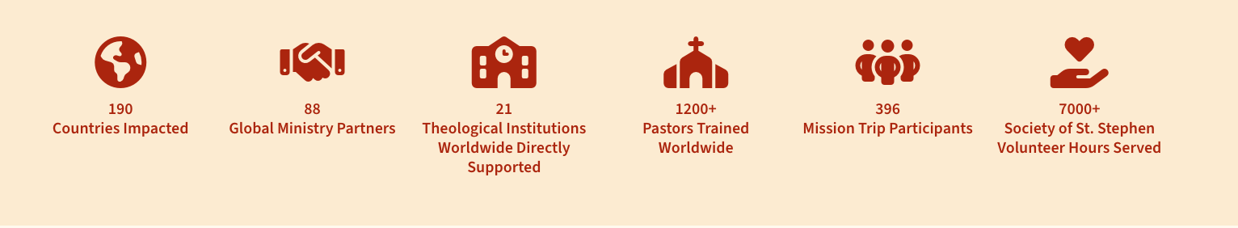

Support Our Gala

The Shepherd | $10,000
- Premier VIP table for 8 guests
- Choose an existing ministry partner to receive $1,000 of your sponsorship
- Program listing and visual credit that highlights your chosen ministry partner
- Exclusive thank you gift from the mission field
- Individual gifts for each of your table guests
- Private reception hour before the event with keynote speakers and pastors

CTA: Purchase Now

The Seeker | $5,000
- Preferred seating for 8 guests
- Choose an existing ministry partner to receive $500 of your sponsorship
- Program listing
- Exclusive thank you gift from the mission field
- Handwritten thank-you card from mission partner

CTA: Purchase Now

The One | $2,000
- Reserved seating for 8 guests
- Exclusive thank you gift from the mission field
- Program listing

CTA: Purchase Now

Gala Single Ticket | $100
- Each ticket provides entrance and seating at the gala. Dinner is included

CTA: Purchase Now

Can’t Attend the Gala

You can still support the work of our Missions Ministry and partners through your generous giving. Every gift helps share Christ’s love in our communities and around the world.

Buttons: Give to Missions | Give to Disaster Relief | Donation Items Needed | Local Partners | Global Partners

Have Questions?

If you would like more information about the Missions Gala, our ministry, sponsorship opportunities, or how to support missions, our team is here to help.

Message Lauren Burnham

Let’s just do my email and not my phone number. Understood. We’ll hyperlink your name with your email.

